Cover Page
SQL DATA ANALYSIS
Project 3
Industrial Training Kit
Submitted By
Harshath Mohammad
Submitted To
DecodeLabs
Batch: 2026

Contents
Introduction 3
Objectives 3
Tools Used 3
Dataset Description 3
Data Visualization 3
Key Insights 9
Conclusion 9

Introduction
Data Visualization is the process of representing data graphically to make patterns, trends, and relationships easier to understand. In this project, an e-commerce sales dataset was analyzed using Python libraries such as Pandas, Matplotlib, and Seaborn. Multiple charts were created to effectively communicate business insights.

Objectives
- Learn data visualization techniques.
- Create meaningful charts.
- Analyze sales data visually.
- Identify business trends.
- Present data effectively.

Tools Used

Tool | Purpose
Python | Programming
Pandas | Data manipulation
Matplotlib | Chart creation
Seaborn | Statistical visualization
Jupyter Notebook | Development environment

Dataset Description
The dataset contains 1200 e-commerce sales records with 14 columns, including order details, products, payment methods, quantities, and total sales values.

Data Visualization
Bar Chart

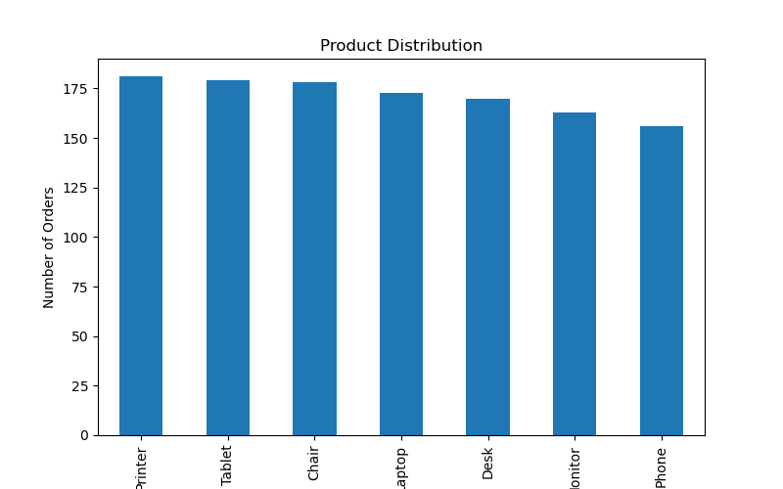
Displays the number of orders for each product category.

Pie Chart
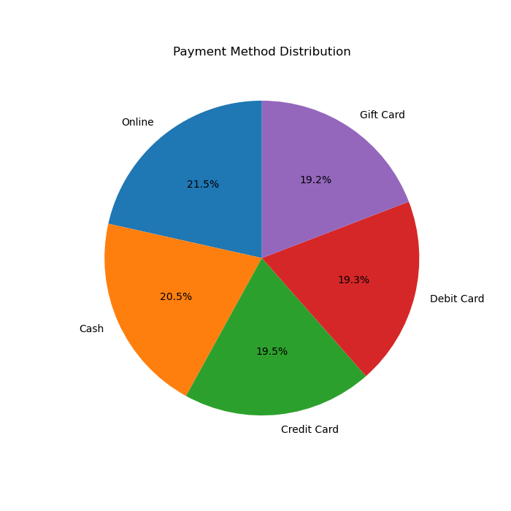

Shows the percentage distribution of payment methods.

Line Chart
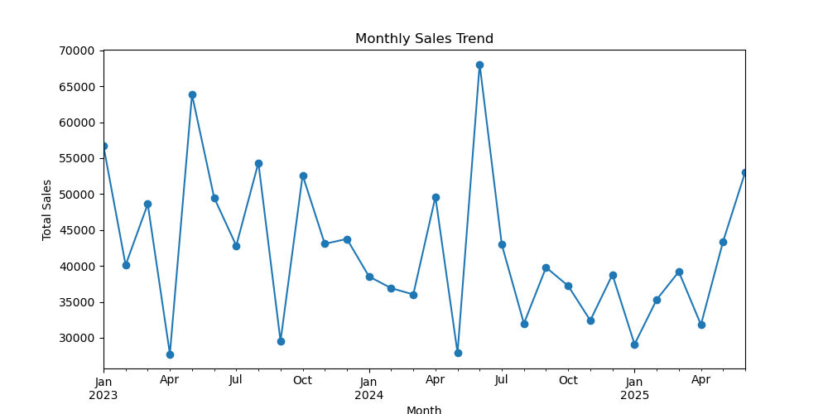

Illustrates the monthly sales trend over time.

Histogram
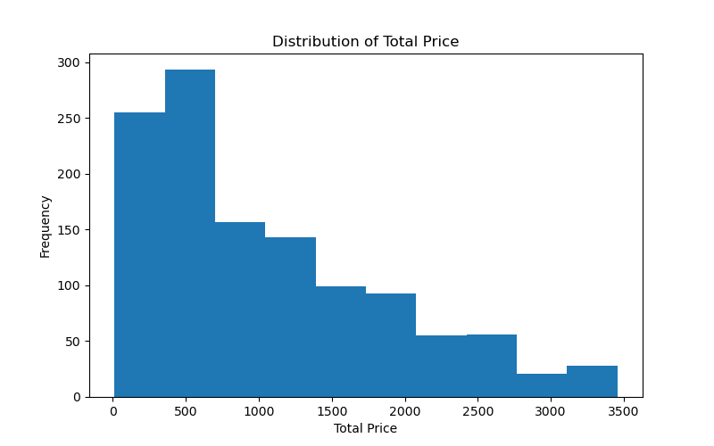
Shows the distribution of total order values.
Box Plot
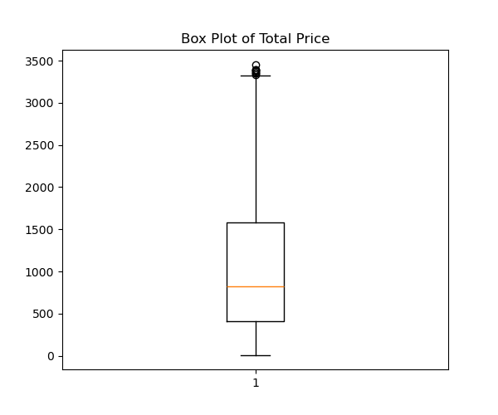

Highlights the spread of total prices and potential outliers.
Scatter Plot
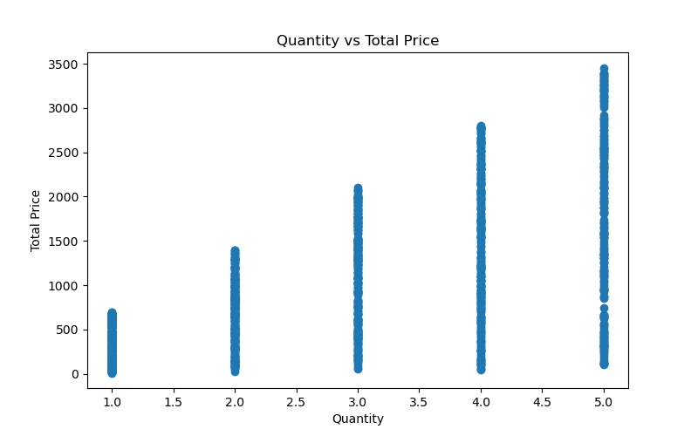

Shows the relationship between quantity purchased and total price.

Heatmap
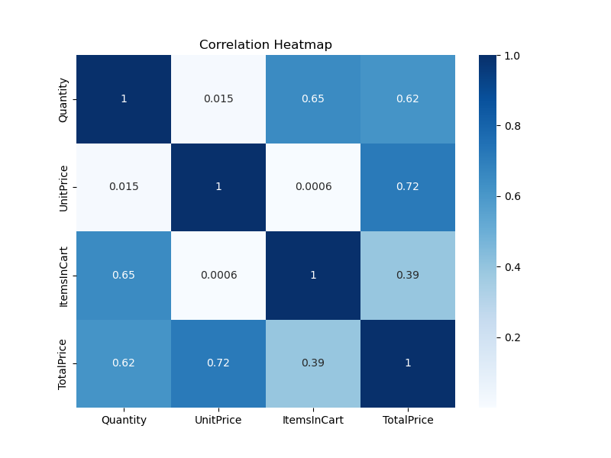

Displays correlations between numerical variables.

Key Insights
• Product demand varies across categories.
• Customers use multiple payment methods with fairly balanced usage.
• Sales fluctuate over different months.
• Most orders fall within a common price range.
• Higher quantities generally lead to higher total prices.
• Numerical features show useful correlations for analysis

Conclusion
This project demonstrated how data visualization helps transform raw data into meaningful insights. By creating different chart types, patterns in sales, customer behavior, and pricing became easier to understand. These visualizations support better business decision-making and improve data interpretation.

